Wireframe Documentation

Entertainer Data Analysis

Last date of revision: 27/05/2024

Divakar K G

[AUTHOR NAME] 1

Table of Contents

Homepage 4

Entertainer Overview Page 5

Movie Overview Page 6

Movie List by Year 8

KPI Light For Oscar won 8

Movie Rating by Movie Name 9

Overall Performance & Metrics Page 9

Award Won by Entertainers 8

Count of Profession & Gender 8

Screenshot 2024-05-25 214958Screenshot 2024-05-25 214958

Home Page

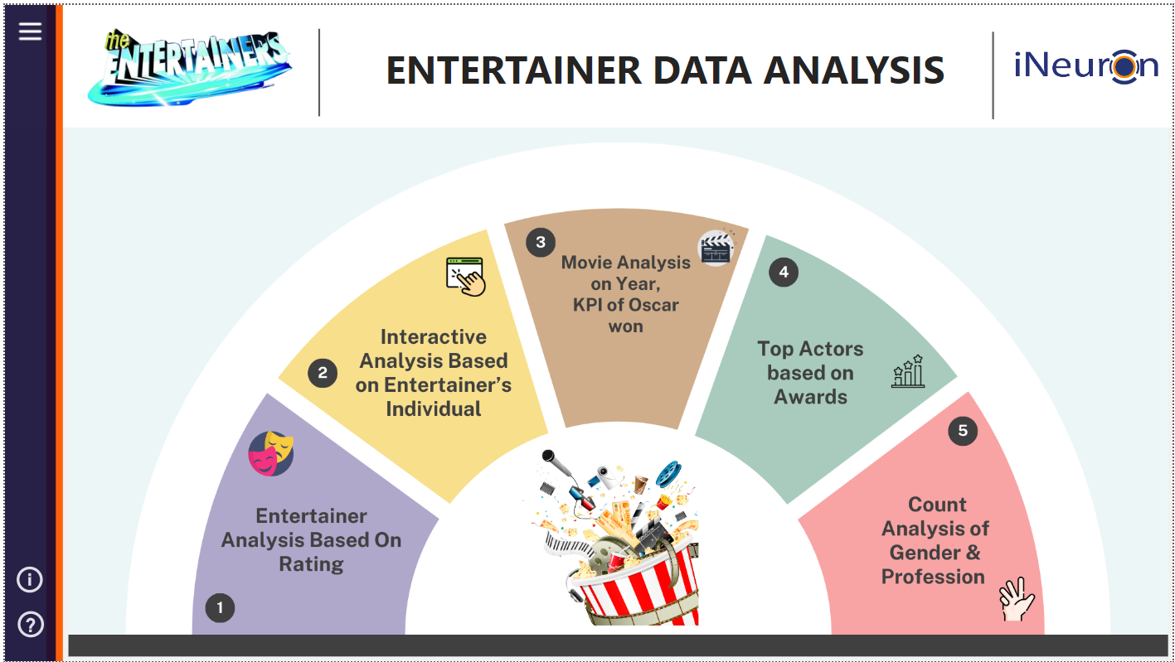

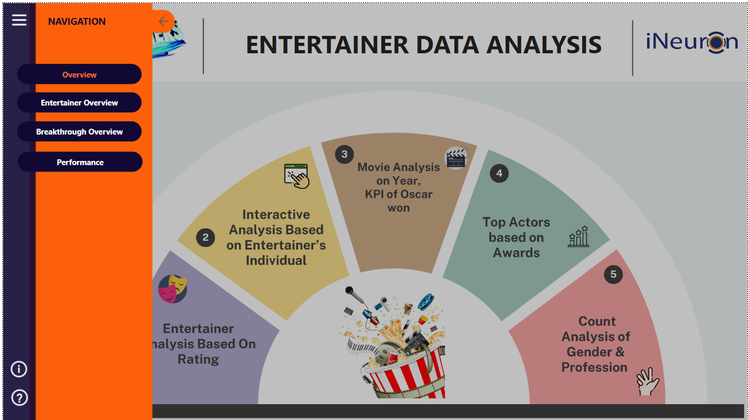

● The homepage features a navigation panel, an Info section, and a Help button to enhance user understanding.

● It also includes a basic overview of how data is visualized and what’s present in the dashboard.

● Users can easily navigate through sections, access detailed documentation, view key metrics, and understand data

trends with sample visualizations, ensuring a seamless and informative experience.

Entertainer’s Overview Page

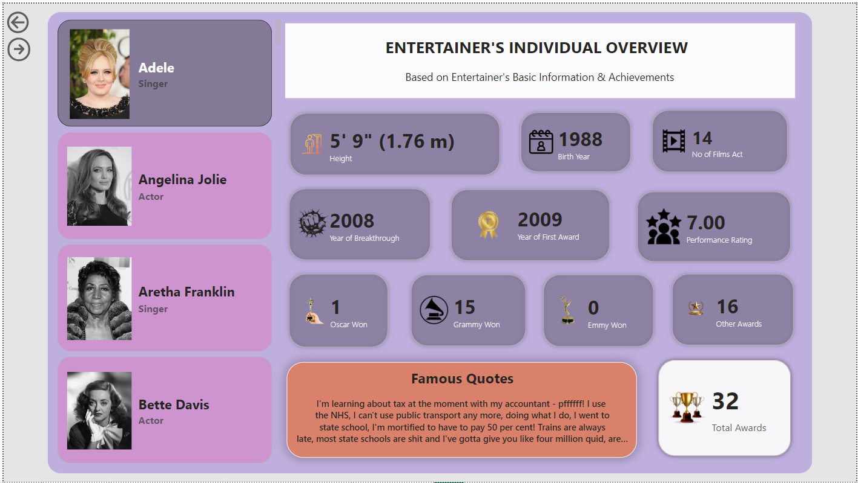

● The Entertainer Overview page offers an interactive experience where users can engage with detailed data for each individual entertainer by clicking on their profile picture.

● Upon selection, users are presented with comprehensive information including the entertainer's height, birth year,

number of films acted in, breakthrough year, year of first award, performance rating, and award achievements.

● Additionally, the page displays famous quotes attributed to the entertainer, providing a well-rounded view of their

career and personal milestones.

● This feature-rich interaction allows users to gain deeper insights into the entertainers' professional journeys and notable accomplishments.

Movie Overview Page

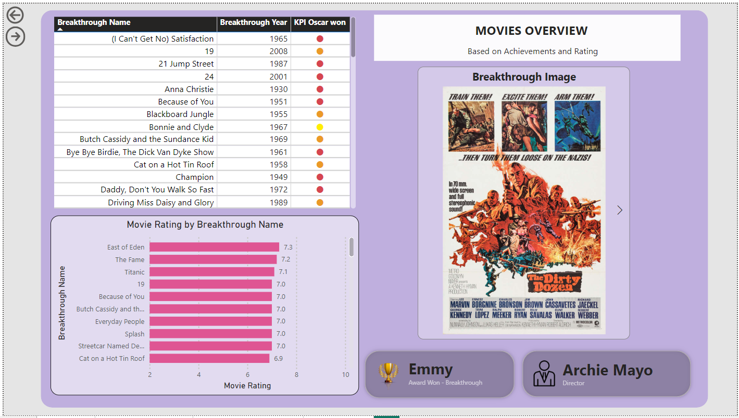

● The Movies Overview page features a table listing breakthrough films alongside their breakthrough year and any

Oscars won.

● Each film is accompanied by a beautiful cover image, enhancing the visual appeal.

● The top movies are prominently displayed with their respective breakthrough names.

● Additionally, the page includes the name of each film's director and a summary of awards won by breakthrough.

● This layout provides users with a comprehensive view of significant films, highlighting their achievements and

key contributors, while also offering an engaging and aesthetically pleasing experience through the inclusion of

cover images.

Overall Performance & Metrics Page

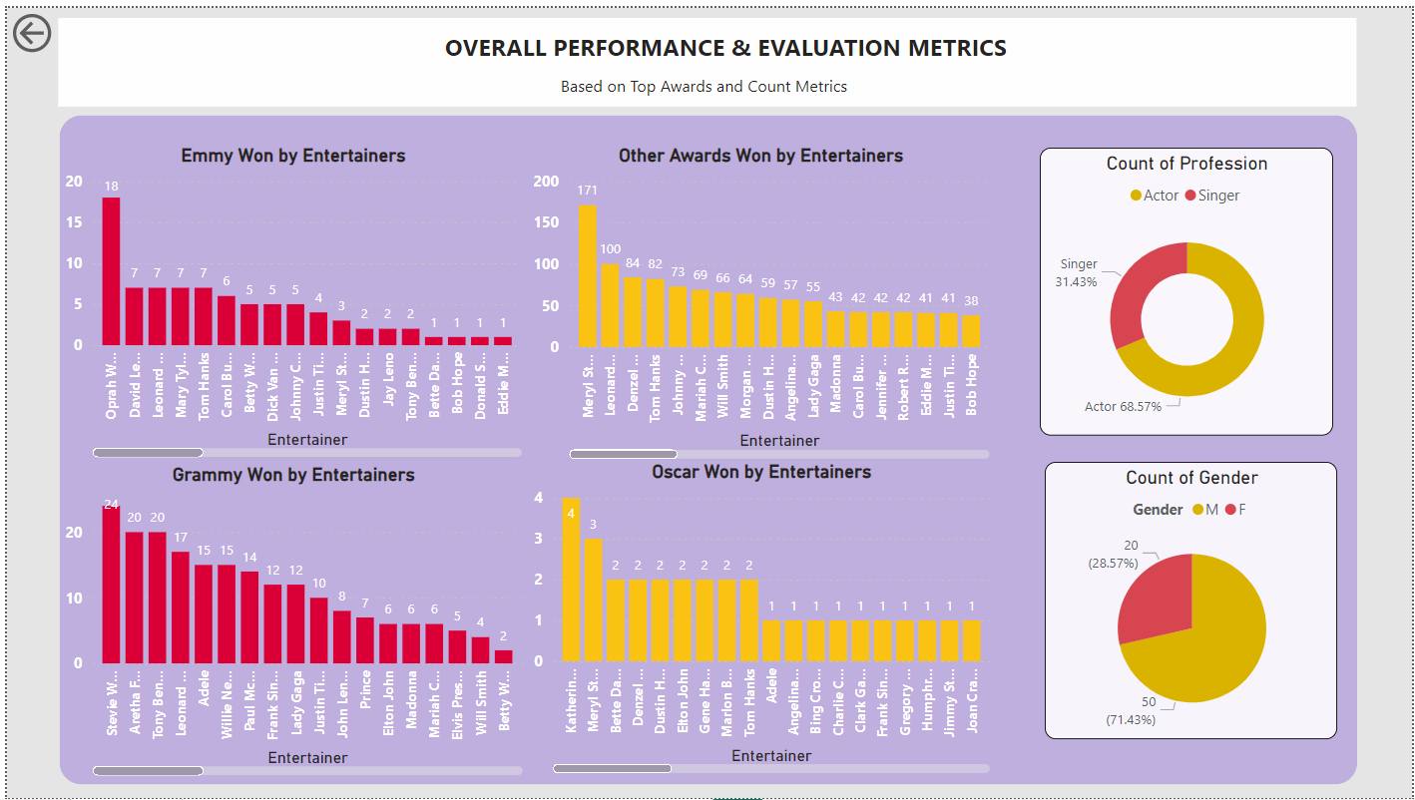

● The Overall Performance & Metrics Page features a clustered chart displaying awards such as Emmy, Grammy, Oscar, and other accolades won by actors, highlighting the top entertainers by their award counts.

● Additionally, the page includes pie and donut charts that depict the distribution of gender and profession within the given dataset.

● These visualizations provide a clear and comprehensive overview of award achievements and demographic breakdowns, allowing users to easily identify trends and patterns among the top entertainers.

● The combination of clustered, pie, and donut charts ensures a detailed and engaging presentation of the data.